Atom Economy

Given that: % Atom economy = Mass of desired product x 100

Total mass of reactants

Work out the economy of the following reactions:

1/ Bromination of cyclohexene
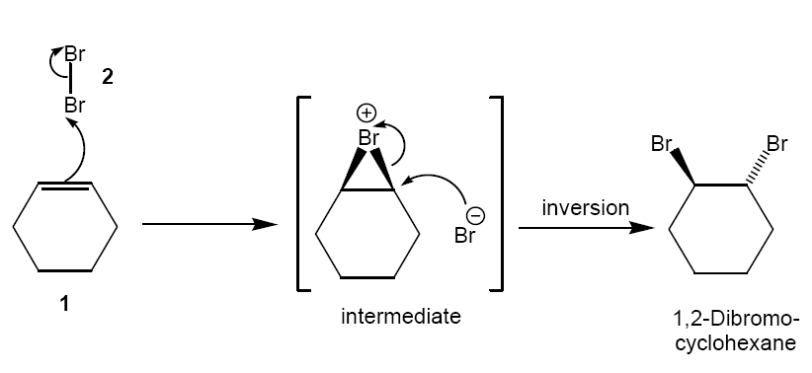

2/ Formation of isobutene
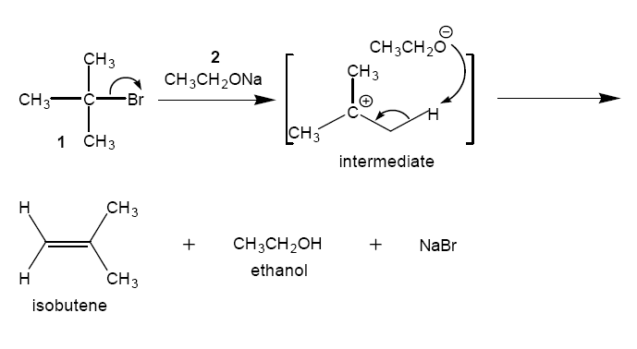

3/ Production of Methyl Propionamide
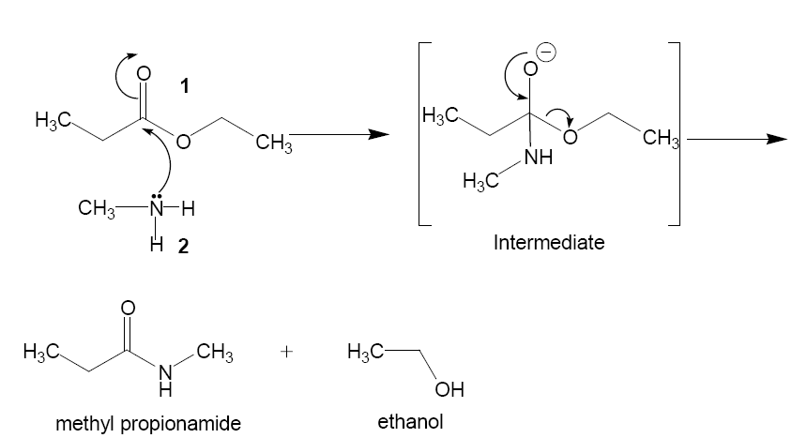

4/ Synthesis of Ethylene Oxide: Which method is better- i or ii?

i/ Chlorohydrin process
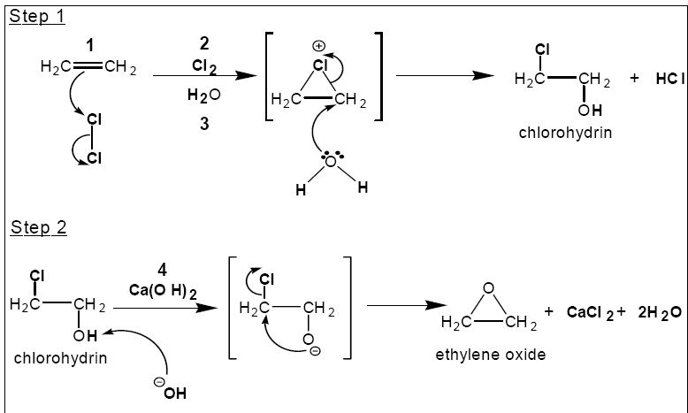

ii/ Catalytic synthesis

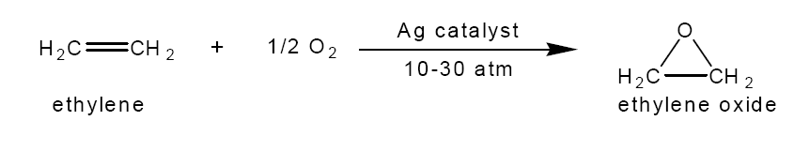

What other factors would you have to take into account when making your product?

