Atom Economy

Given that: % Atom economy = Mass of desired product x 100

Total mass of reactants

Work out the economy of the following reactions:

1/ Bromination of cyclohexene
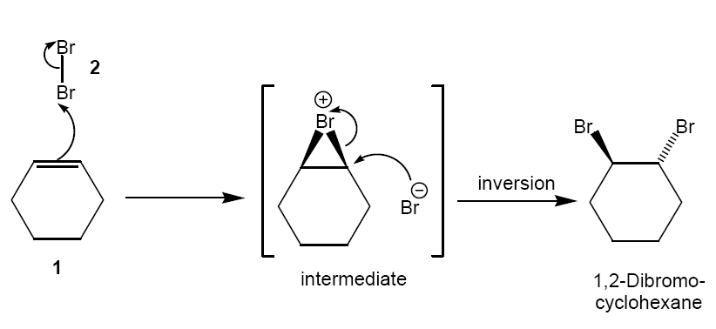
Reactants: C₆H₁₀ RFM = (6x12) + (10x1) = 82
Br₂ RFM = (2x79.9) = 159.8

Products: C₆H₁₀Br₂ RFM = (6x12) + (10x1) + (2x79.9) = 241.8

% atom economy = 241.8 x 100 = 100%
(82+159.8)

2/ Formation of isobutene
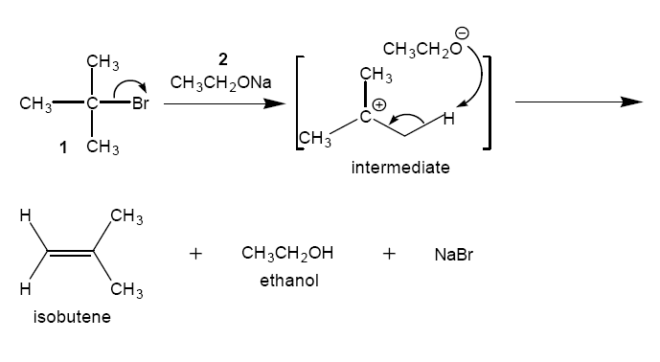
Reactants: C₄H₉Br RFM = (4x12) + (9x1) + (1x79.9)
= 136.9
CH₃CH₂ONa RFM = (2x12) x (5x1) + (1x16) + (1x23)
= 68

Products: C₄H₈ RFM = (4x12) + (8x1) = 56

% atom economy = 56 x 100 = 27%
(136.9+68)

3/ Production of Methyl Propionamide
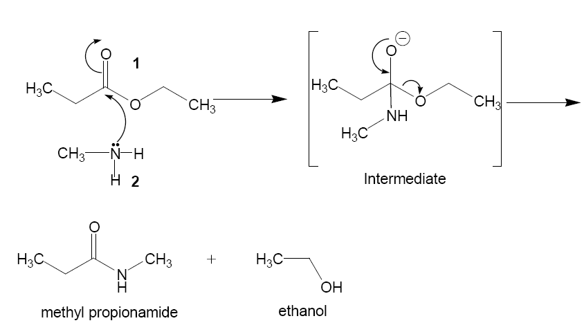

Reactants: C₅H₁₀O₂ RFM = (5x12) + (10x1) + (2x16) = 102
CH₅N RFM = (1x12) + (5x1) + (1x14) = 31

Products: C₄H₉O RFM = (4x12) + (9x1) + (1x16) = 87

% atom economy = 87 x 100 = 65`%
(102 + 31)

4/ Synthesis of Ethylene Oxide: Which method is better- i or ii?

i/ Chlorohydrin process
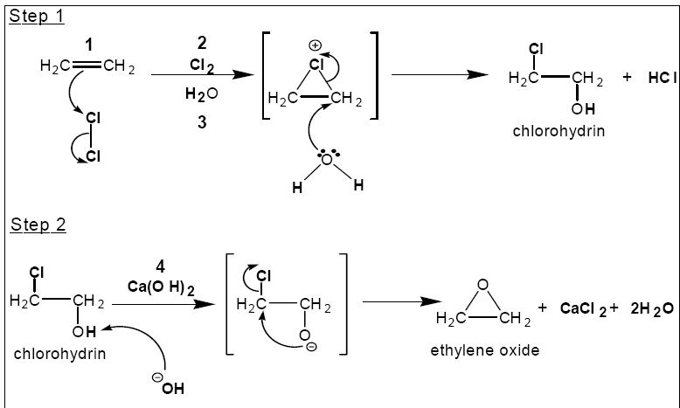

Reactants: C₂H₄ RFM = (2x12) + (4x1) = 28
Cl₂ RFM = (2x35.5) = 71
H₂O RFM = (2x1) + (1x16) = 18
Ca(OH)₂ RFM = (1x 40.1) + (2x1) + (2x16) = 74.1

Products: C₂H₄O RFM = (2x12) + (4x1) + (1x16) = 44

% atom economy = 44 x 100 = 23%
(28 + 71 + 18 + 74.1)

ii/ Catalytic synthesis

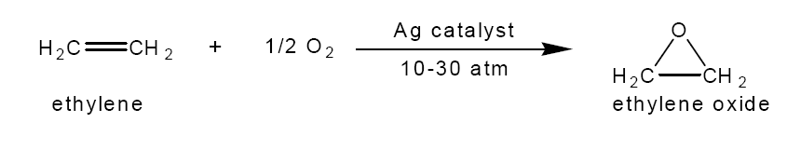
Reactants: C₂H₄ RFM = (2x12) + (4x1) = 28
½O₂ RFM = (1x16) = 16

Products: C₂H₄O RFM = (2x12) + (4x1) + (1x16) = 44

% atom economy = 44 x 100 = 100%
(28 + 16)

What other factors would you have to take into account when making your product?

Initial cost of catalyst (can it be recovered and re-used?)
Cost of apparatus and power to operate at pressure
Cost of disposal of waste products from rxn 4i

