AS.CHEM1.2.010 30-Jul-26 © Ripon Grammar School / RWGrime  PERCENTAGE YIELD & ATOM ECONOMY  Name ………………………………………….………………………………. Form …………………. | 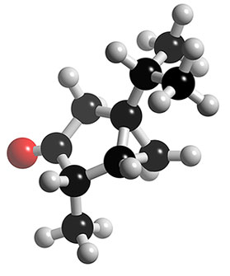

PART 1 – PERCENTAGE YIELD

1) Sulfur dioxide reacts with oxygen to make sulfur trioxide. 2 SO₂ + O₂ → 2 SO₃

a) Calculate the maximum theoretical mass of sulfur trioxide that can be made by reacting 96 g of sulfur dioxide with an excess of oxygen.

b) In the reaction, only 90 g of sulfur trioxide was made. Calculate the percentage yield.

c) Give three reasons why the amount of sulfur trioxide made is less than the maximum theoretical maximum.

2) Iron is extracted from iron oxide in the Blast Furnace as shown. Fe₂O₃ + 3 CO → 2 Fe + 3 CO₂

a) Calculate the maximum theoretical mass of iron that can be made from 1 tonne of iron oxide.

b) In the reaction, only 650000 g of iron was made. Calculate the percentage yield.

3) Nitrogen reacts with hydrogen to make ammonia. N₂ + 3 H₂ → 2 NH₃

a) Calculate the maximum theoretical mass of ammonia that can be made by reacting 90 g of hydrogen with an excess of nitrogen.

b) In the reaction, only 153 g of ammonia was produced. Calculate the percentage yield.

4) Titanium can be extracted from titanium chloride by the following reaction. TiCl₄ + 2 Mg → Ti + 2 MgCl₂

a) Calculate the maximum theoretical mass of titanium that can be extracted from 100 g of titanium chloride .

b) In the reaction, only 20 g of titanium was made. Calculate the percentage yield.

c) Give three reasons why the amount of titanium made is less than the maximum theoretical maximum.

5) Aluminium is extracted from aluminium oxide in the following reaction. 2 Al₂O₃ → 4 Al + 3 O₂

a) Calculate the maximum theoretical mass of aluminium that can be made from 1 kg of aluminium oxide.

b) In the reaction, only 500 g of aluminium was made. Calculate the percentage yield.

6) The fertiliser ammonium sulpfate is made as follows. 2 NH₃ + H₂SO₄ → (NH₄)₂SO₄

a) Calculate the maximum theoretical mass of ammonium sulfate that can be made by reacting 85 g of ammonia with an excess of sulfuric acid.

b) In the reaction, only 300 g of ammonium sulfate was produced. Calculate the percentage yield.

7) 0.8500 g of hexanone, C₆H₁₂O, is converted into its 2,4-dinitrophenylhyrazone during its analysis. After isolation and purification, 2.1180 g of product C₁₂H₁₈N₄O₄ are obtained. Calculate the percentage yield.

PART 2 – ATOM ECONOMY

8) Calculate the atom economy to make sodium from sodium chloride. | 2 NaCl → 2 Na + Cl₂
9) Calculate the atom economy to make hydrogen from the reaction of zinc with hydrochloric acid. | Zn + 2 HCl → ZnCl₂ + H₂
10) Calculate the atom economy to make iron from iron oxide in the Blast Furnace. | Fe₂O₃ + 3 CO → 2 Fe + 3 CO₂
11) Calculate the atom economy to make calcium oxide from calcium carbonate. | CaCO₃ → CaO + CO₂
12) Calculate the atom economy to make sulfur trioxide from sulfur dioxide. | 2 SO₂ + O₂ → 2 SO₃
13) Calculate the atom economy to make oxygen from hydrogen peroxide. | 2 H₂O₂ → 2 H₂O + O₂

PART 3 – GENERAL QUESTIONS

14) Hydrazine (N₂H₄) was used as the rocket fuel for the Apollo missions to the moon. It is by reaction of ammonia (NH₃) with sodium chlorate (NaOCl).

ammonia + sodium chlorate → hydrazine + sodium chloride + water
2 NH₃ + NaOCl → N₂H₄ + NaCl + H₂O

a) Calculate the maximum theoretical mass of hydrazine that can be made by reacting 340 g of ammonia with an excess of sodium chlorate.

b) In the reaction, only 280 g of hydrazine was produced. Calculate the percentage yield.

c) Calculate the atom economy for this way of making hydrazine.

15) Ibuprofen is a common pain killer used for symptoms such as head aches, tooth ache and period pains. It was invented in the 1960’s by Boots and became available without a prescription in the 1980’s.  In the original method for making ibuprofen the atom economy was 40%. However, a new way of making ibuprofen was invented in the 1980’s that had an atom economy of 77%. This means there is less waste to dispose of and so is a “greener” way of making ibuprofen. The method is also cheaper. | 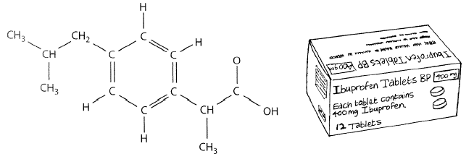

Sustainable development is where we do what we need to meet peoples’ needs and improve their lives today in a way that does not stop people from meeting the needs of people in the future. Often, the higher the atom economy the better a process for sustainable development because there is less waste.

a) The newer method has a much better atom economy of 77%. Explain why a higher atom economy is better.

b) About 3000 tonnes of ibuprofen tablets are taken in the UK each year. Calculate the mass of waste created making 3000 tonnes of ibuprofen tablets at an atom economy of 40%.

c) Calculate the mass of waste created making 3000 tonnes of ibuprofen tablets at an atom economy of 77%.

d) Calculate how much less waste is produced making 3000 tonnes of ibuprofen tablets by the new method compared to the old method.

